1- ubuntu, debian and kubuntu
2- for given details about any command
3- rm for removing directory or file while rmdir for removing empty directories
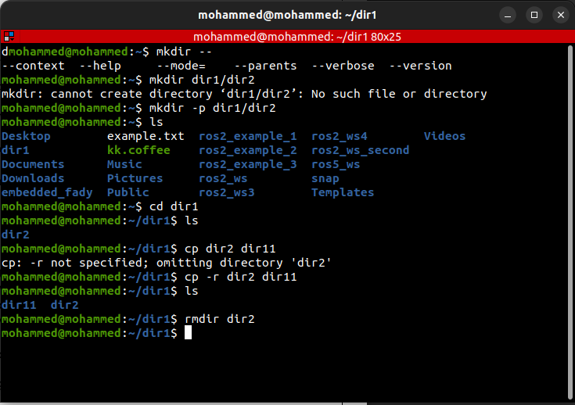
4- a-it can’t be deleted using this command as it used to delete empty directory, so you can use rm -rf to remove it
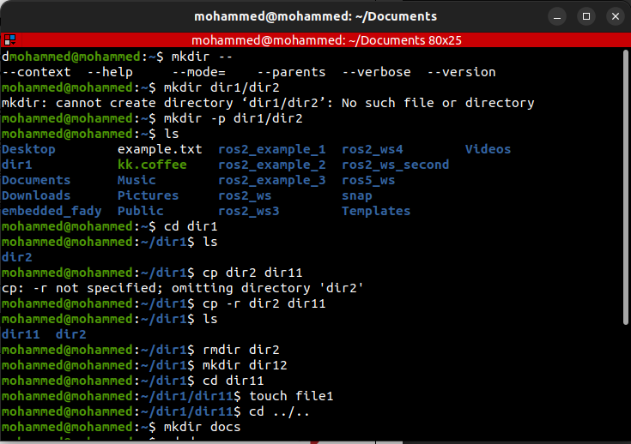
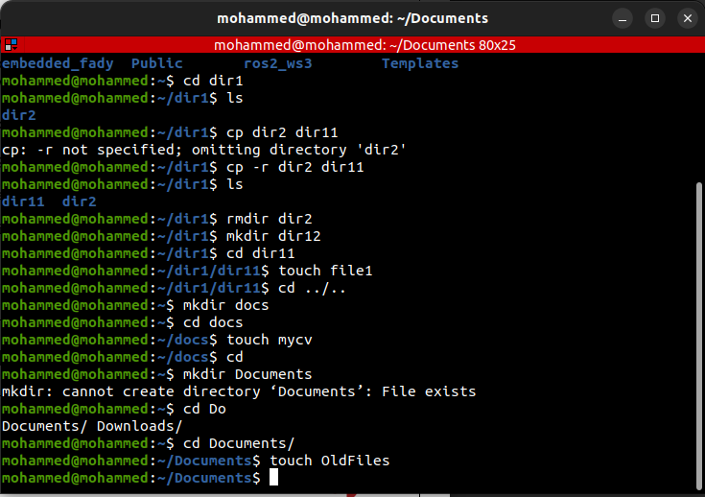
b- it didn’t delete the file
c- absolute path: /home/mohmmed/docs/mycv
relative path: docs/mycv
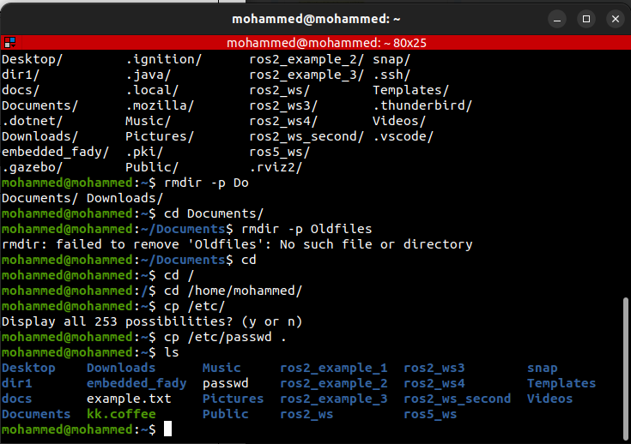
6-

Relative path: /lab-1/docs
7- a - using cd
b- using cd ~
c- using cd $HOME
d- using ../home/mohammed
8- w watchgnupg wget whiptail winicontoppm write
w3m wayland-scanner whatis who wish write.ul
w3mman wbmptopbm whereis whoami wish8.6 www-browser
wall wc which whoopsie word-list-compress
watch wdctl which.debianutils whoopsie-preferences wpa_passphrase
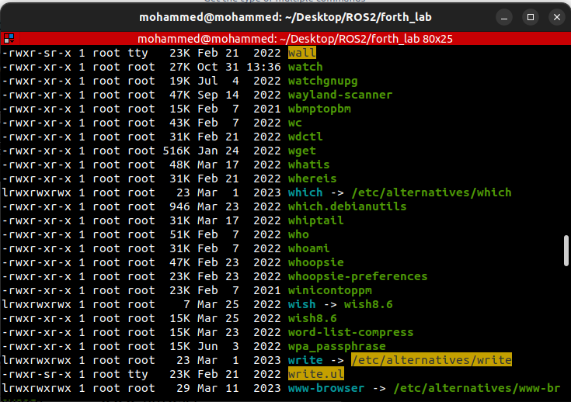
9- give us the type of the command like whether is built-in command or not, where its executable is located and whether it is aliased to some other command
10-
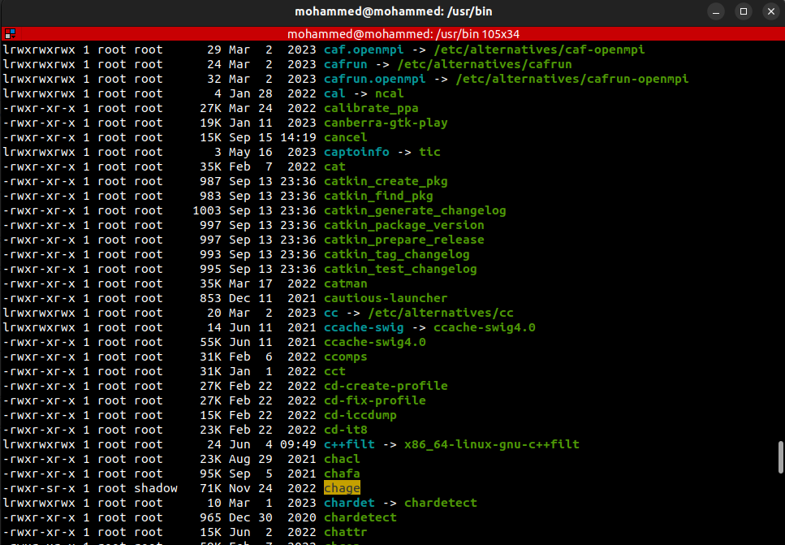
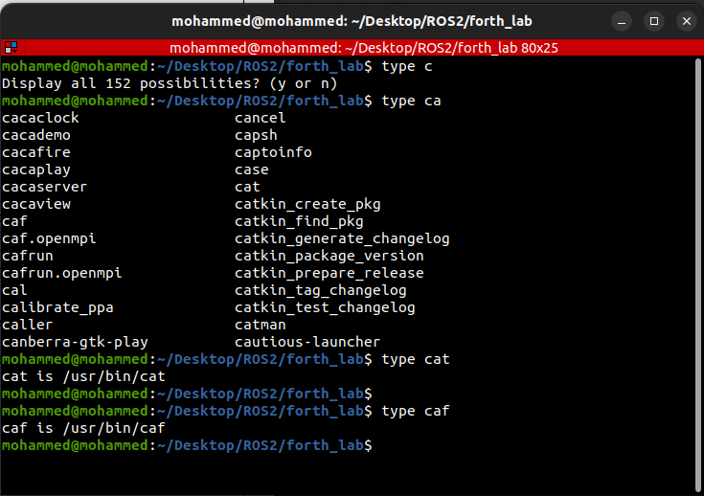
11-

12- used for list all commands related to the keyword you provided

